\***This method is available on the version of Cura V5.1.1 and above, the old version of Cura may cause import failure.**

**If you would like to use the SV06 with the original Cura, please follow the two methods listed below.**

1. Method A：Modify dimensions and parameters directly on the SV01 model in Cura, and import the configuration of SV06 for use

Steps：

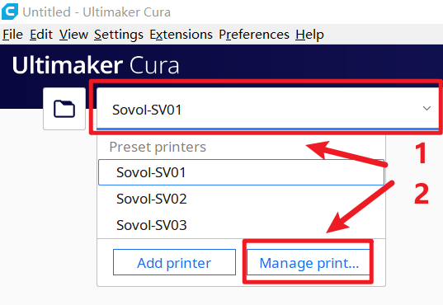

1. Choose the printer version in Cura and enter Manage Printer

*If you have not add the Sovol-SV01 in the Cura, please add it to the Cura first.

Way to add the Sovol-SV01:

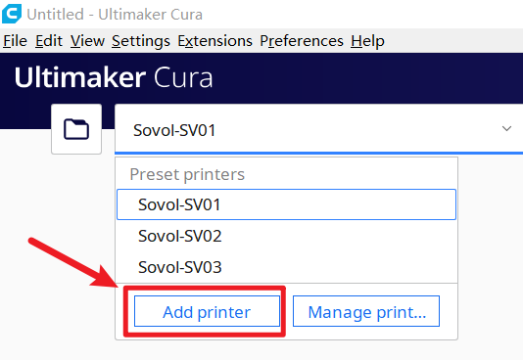

a.Add printer

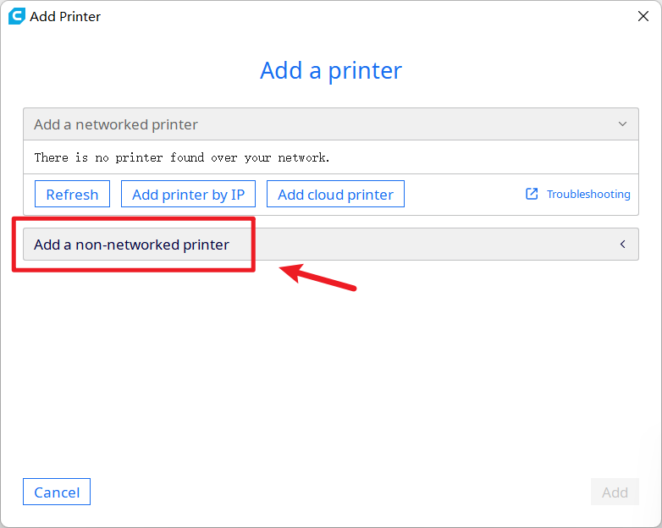

b.Click Add a non-networked printer

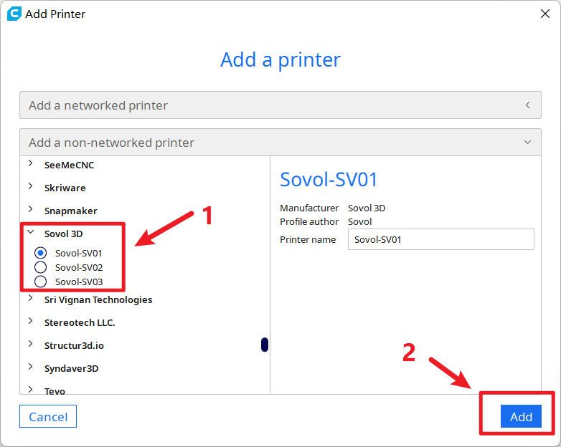

c.Find the Sovol3D and choose Sovol-SV01 and then click add

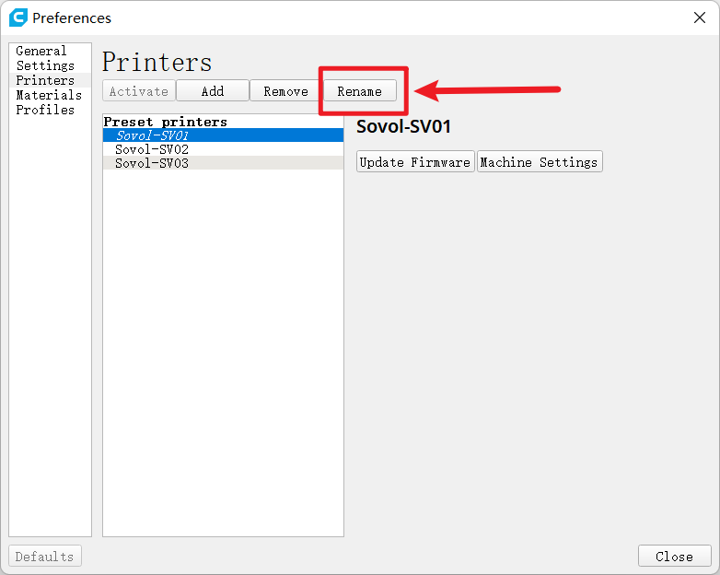

* 1. Rename after selecting the Sovol-SV01

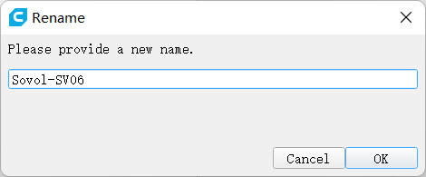

1. Amend the name to Sovol-SV06 and click OK

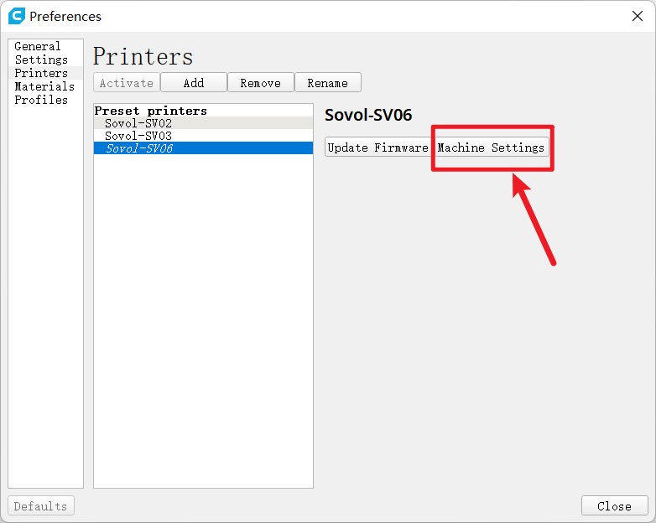

1. Then click Machine Settings

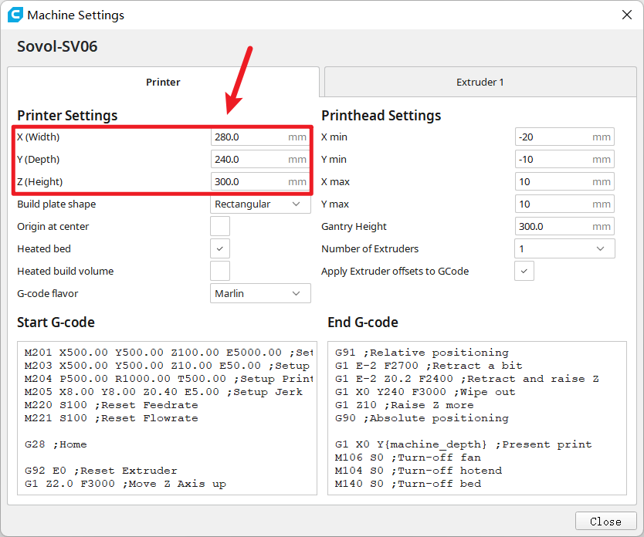

1. Modify the machine dimensions for this section

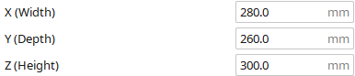

(before)

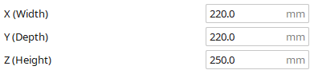

（after）

1. Amend the original value to ( X:220 Y:220 Z:250 )

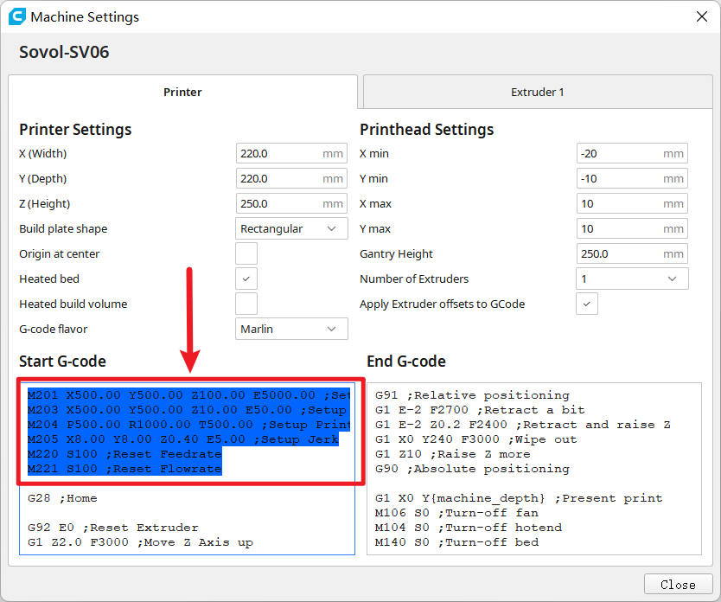

1. Delete the part before G28 ;Home in the Start G-code and click Close

*It is better to click and check again after modifying all parameters

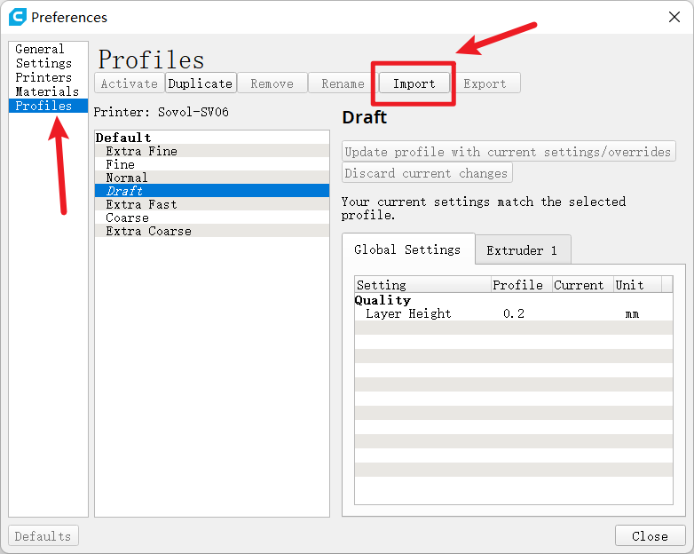

1. In the Preferences interface, select the Profiles on the left side and click Import（the interface after clicking Manage Printer）

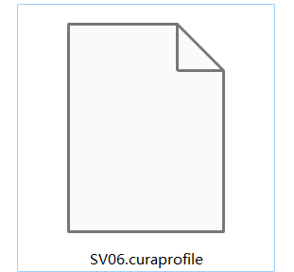

1. Choose to import the above file from in the TF card that sent with the printer.

First Method Done

1. Method B：Add file directly in Cura source files

Detailed steps are as follows：

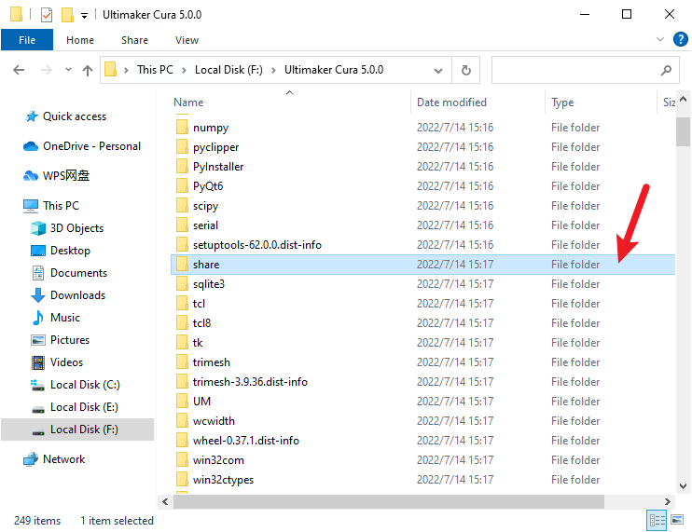

1. Open the Cura software location

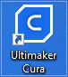 

*If you do not find it, you can right-click the Cura icon on your desktop and click Open file location like the way shown in the picture above.



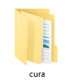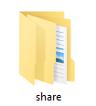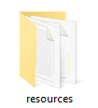

1. Find the folder named share, click to enter, and then enter the cura, resources folder in turn,，

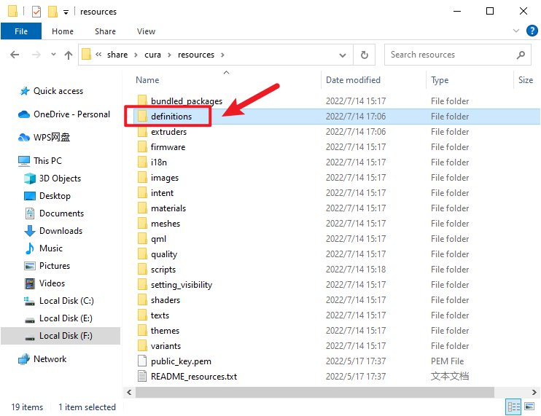

1. Find the definitions folder and open it,

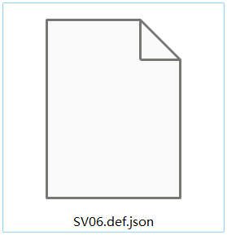

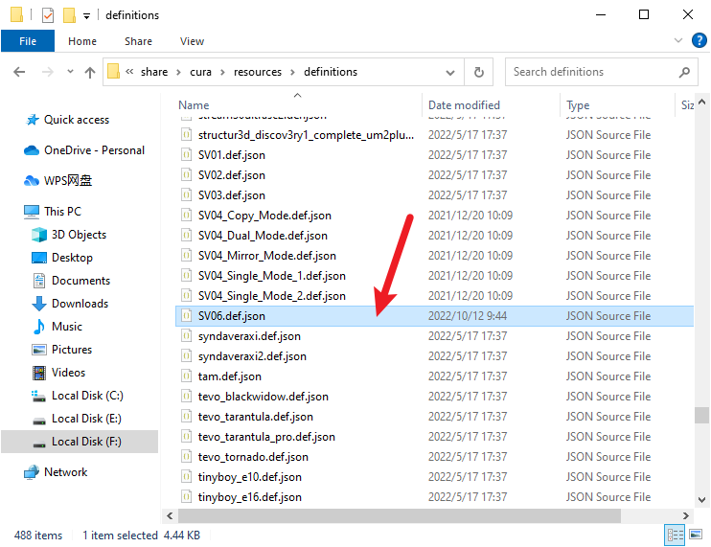

1. Then drag this file SV06.def.json into the definitions folder

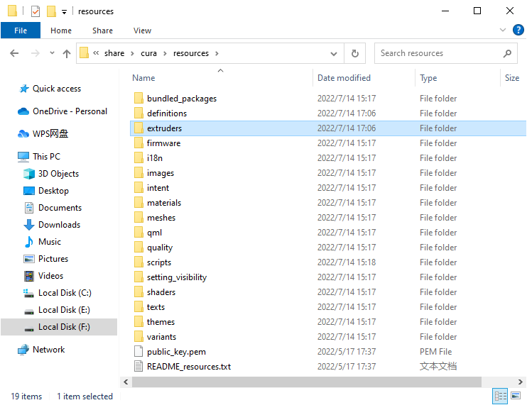

1. Return to the resources folder and find the extruders folder and open

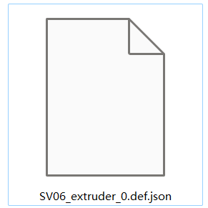

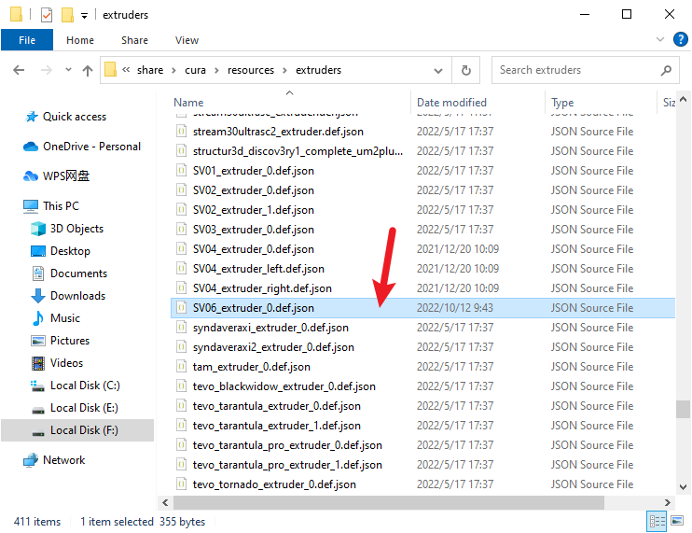

1. Then drag this file SV06_extruder_0.def.json into theextruders folder

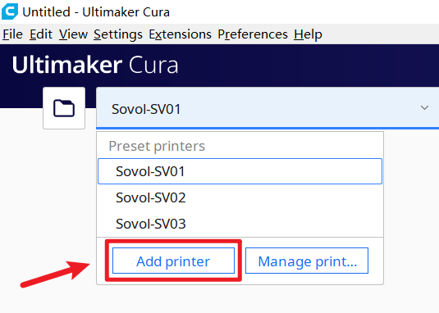

1. Restart the Cura and click add printer



1. Choose and click Add a non-netwoked printer

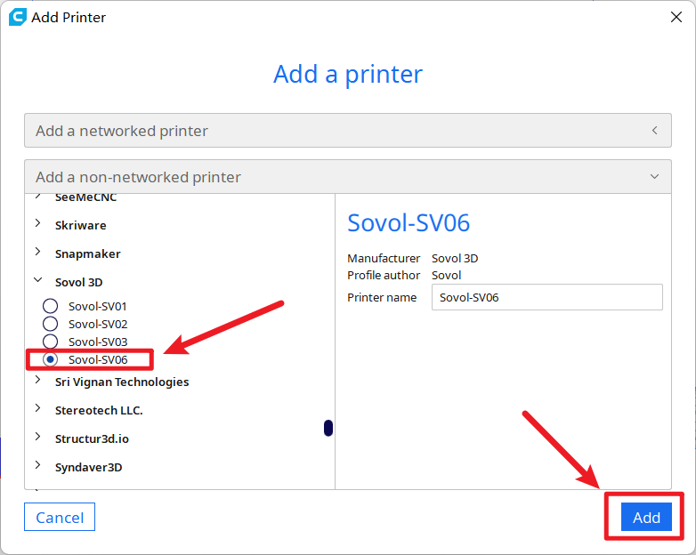

1. Then click and add the Sovol-SV06

The Second Method Done